SQL Functions using Python
Aim
To perform SQL aggregate functions such as COUNT(), SUM(), AVG(), MIN(), MAX(), along with GROUP BY and ORDER BY using Python and SQLite.
Description
This program connects to an SQLite database using Python and creates a Sales table. It inserts sample sales data and demonstrates the use of SQL aggregate functions to summarize the data. It also groups records by product using GROUP BY and sorts the records using ORDER BY.
Python Code
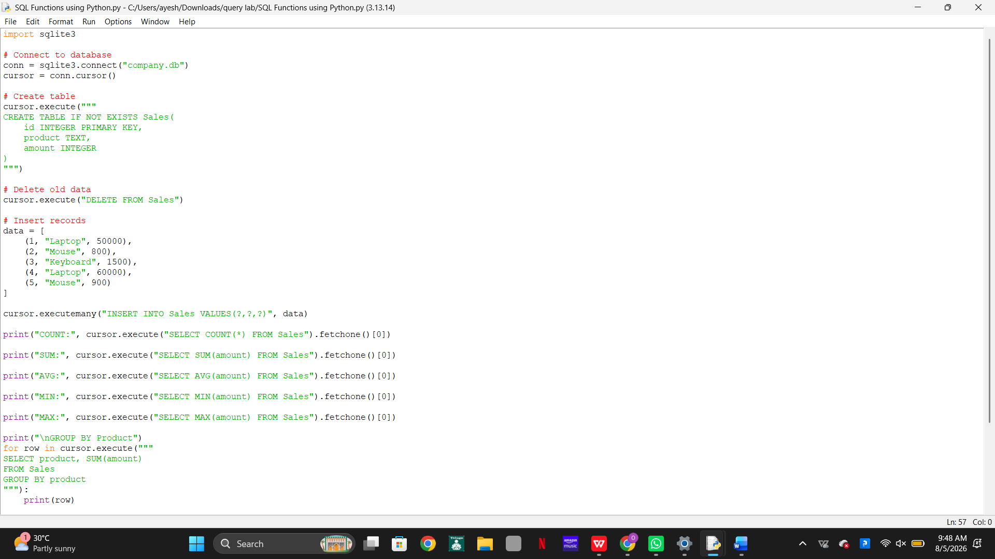
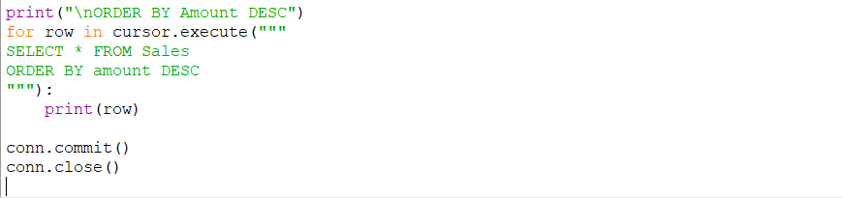
Output
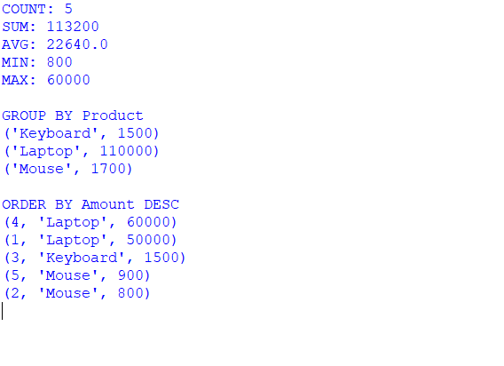
Result
The program successfully performs SQL aggregate functions, groups records based on products, sorts the records in descending order, and displays the summarized results.

Program 2: INNER JOIN using Python
Aim
To perform INNER JOIN using Python and SQLite.
Description
This program creates two tables, Customers and Orders, and inserts sample records. It uses the INNER JOIN operation to retrieve only the matching records from both tables based on the common cust_id field.
Python Code
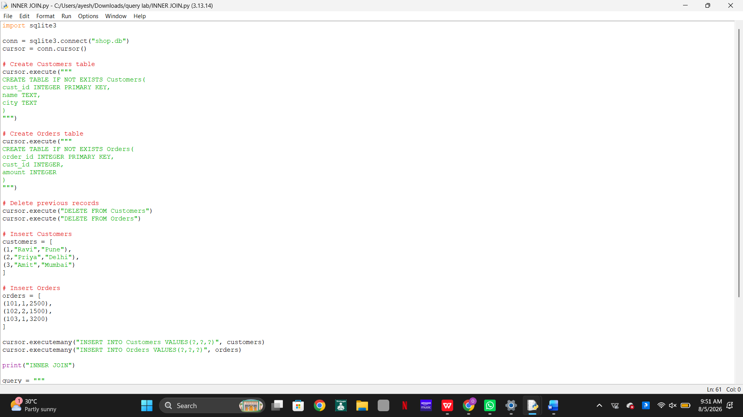
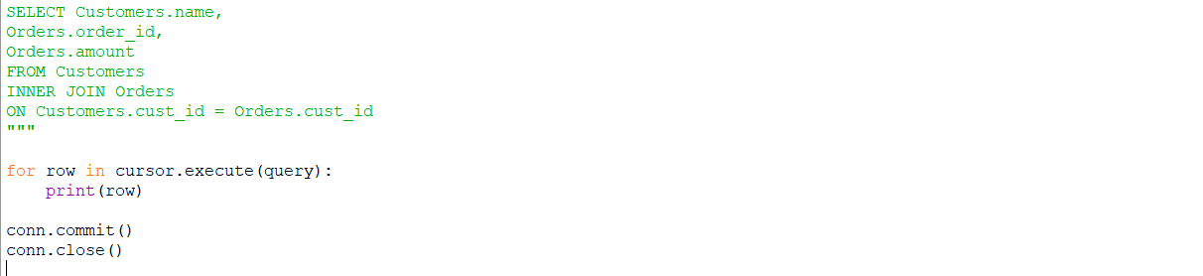

Output
Result
The program successfully displays only the records where matching customer IDs exist in both the Customers and Orders tables.

Program 3: LEFT JOIN using Python
Aim
To perform a LEFT JOIN between two tables using Python and SQLite.
Description
This program joins the Customers and Orders tables using LEFT JOIN. It displays all records from the Customers table and the matching records from the Orders table. If no matching order exists, the corresponding values are displayed as NULL.
Python Code

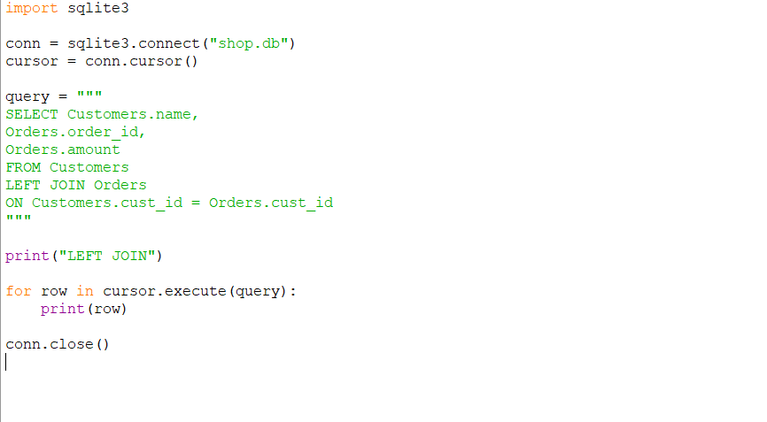Output

Result
The program successfully displays all customer records along with their orders, including customers who have not placed any orders.

Program 4: RIGHT JOIN (SQLite Alternative)
Aim
To demonstrate the RIGHT JOIN concept using Python and SQLite.
Description
Since SQLite does not support the RIGHT JOIN operation directly, this program performs the equivalent operation by reversing the tables and using a LEFT JOIN. It retrieves all records from the Orders table along with the matching customer information.
Python Code
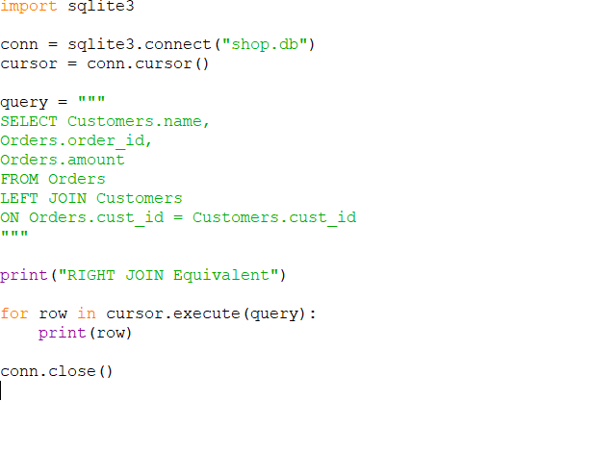

Output:

Result
The program successfully displays all order records with their corresponding customer details using the RIGHT JOIN equivalent query.

Program 5: FULL JOIN (SQLite Alternative)
Aim
To demonstrate the FULL OUTER JOIN concept using Python and SQLite.
Description
SQLite does not directly support FULL OUTER JOIN. This program simulates a FULL OUTER JOIN by combining the results of two LEFT JOIN queries using the UNION operator. It returns all records from both tables, whether matching or not.
Python Code

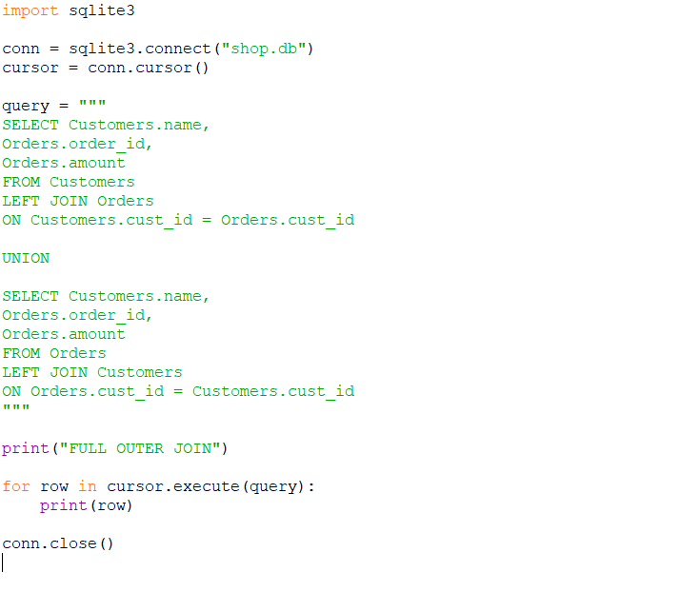
Output :
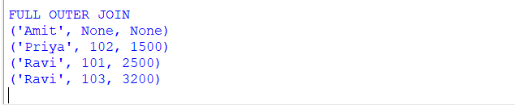
Result
The program successfully displays all records from both the Customers and Orders tables, including matched and unmatched records, thereby simulating a FULL OUTER JOIN.

